/* Ashok

Parameters Lab

6.9.19*/ “Explanation for each report in on this right side of preview report”

1… Sales by Year FULL

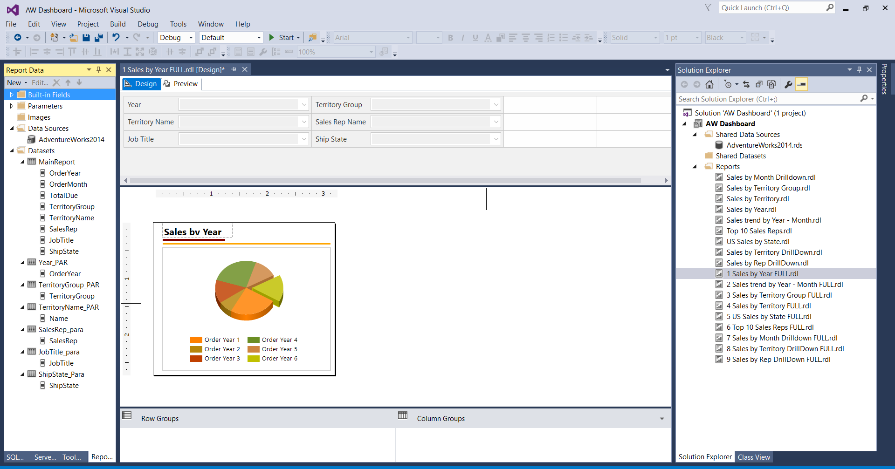

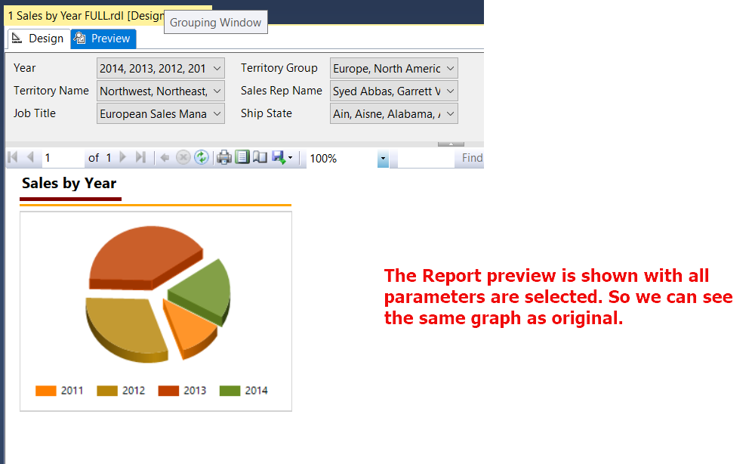

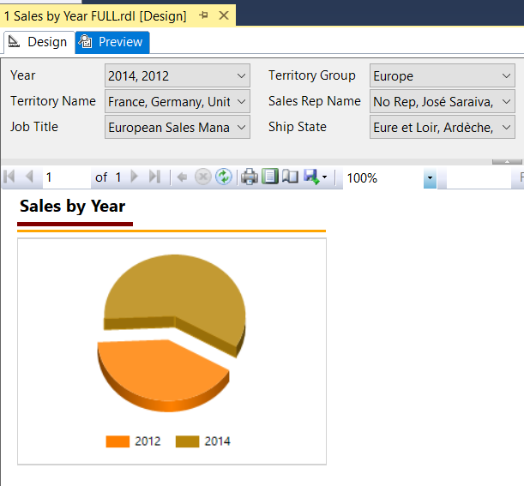

Report Preview with selected parameters. I have selected 2014, 2012 from YEAR and Territory Group as Europe. So we can see the change in chart.

2.. Sales trend by Year - Month FULL

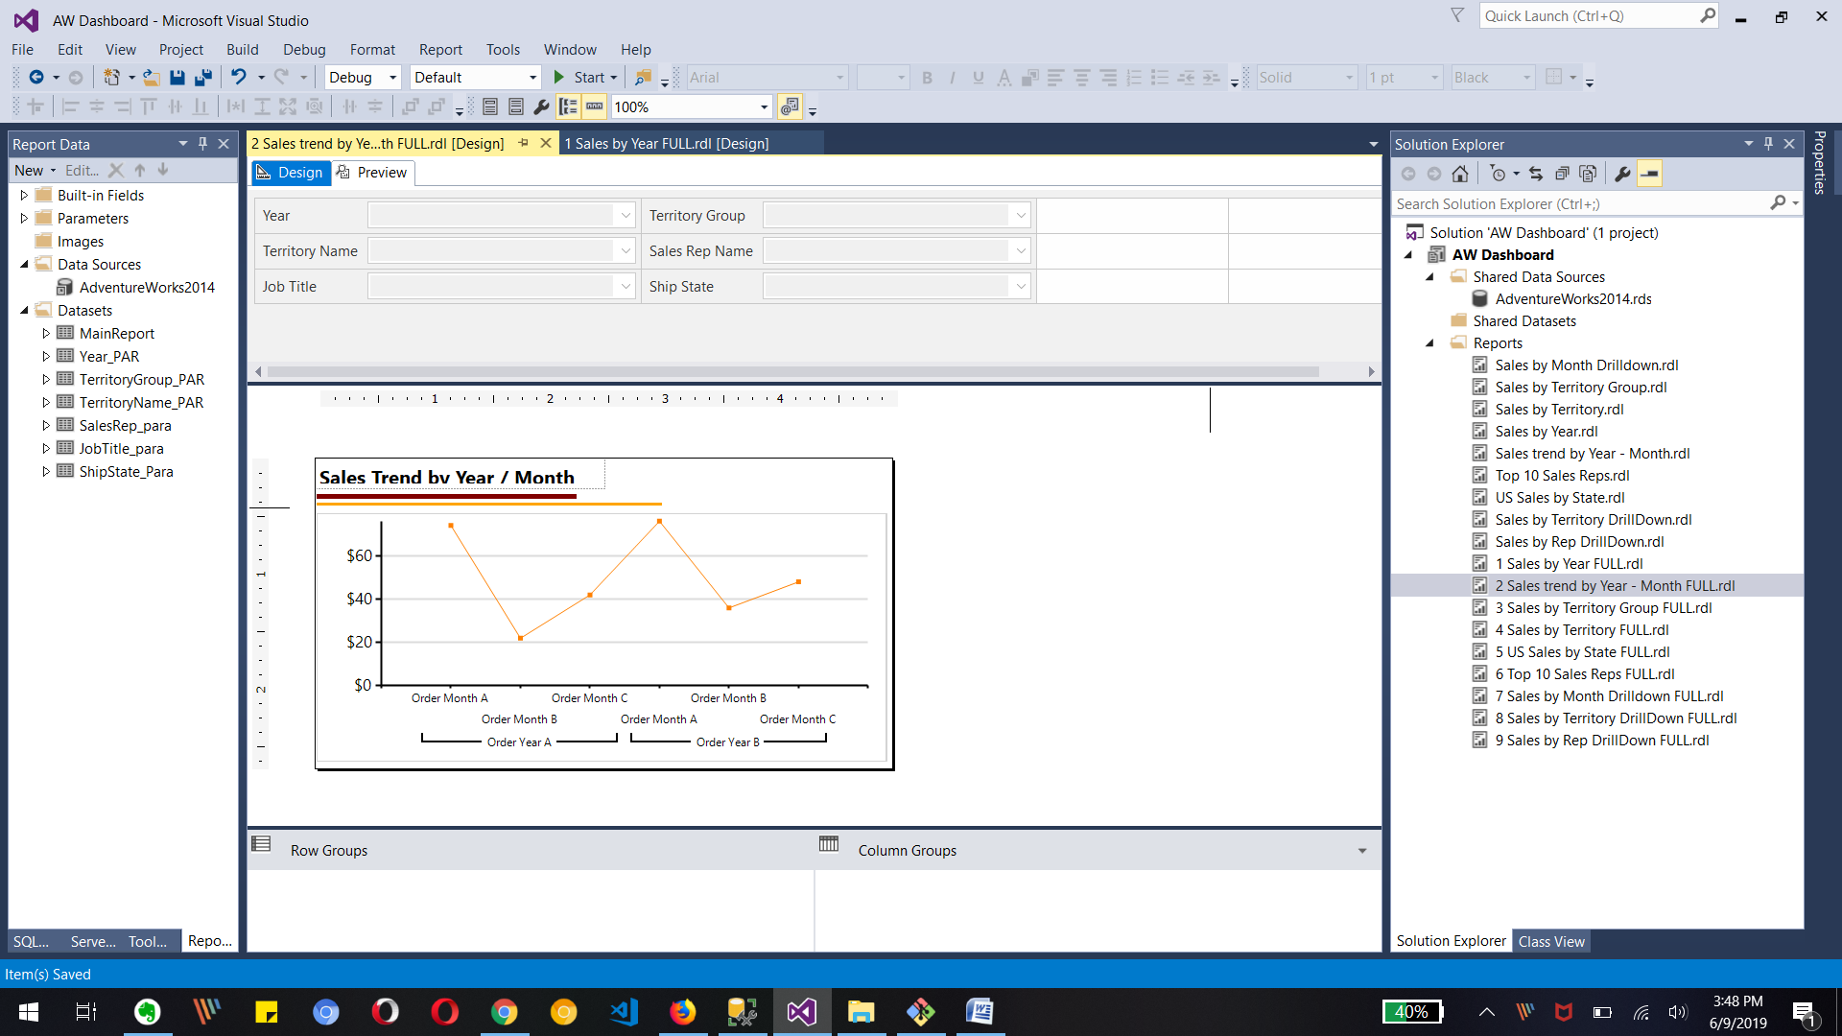

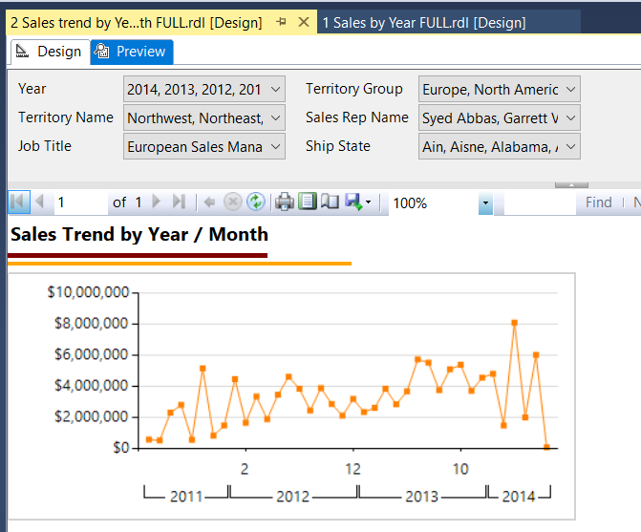The Preview is as default with all selected parameters so we can see most of year and trend in chart.

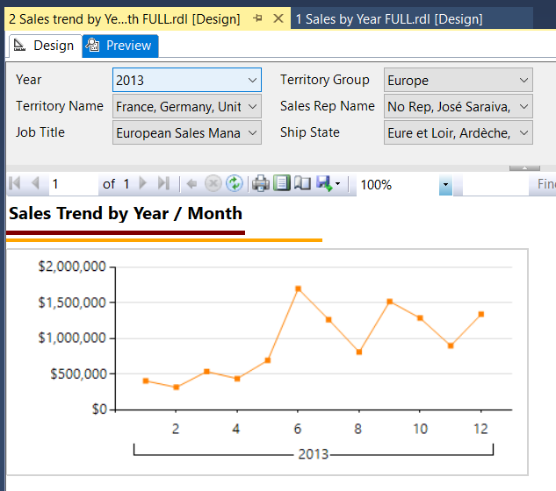This right report is filtered with 2013 as year and Europe as Territory Group.

We can see the changes in graph compare to original one.

3.. Sales by Territory Group FULL

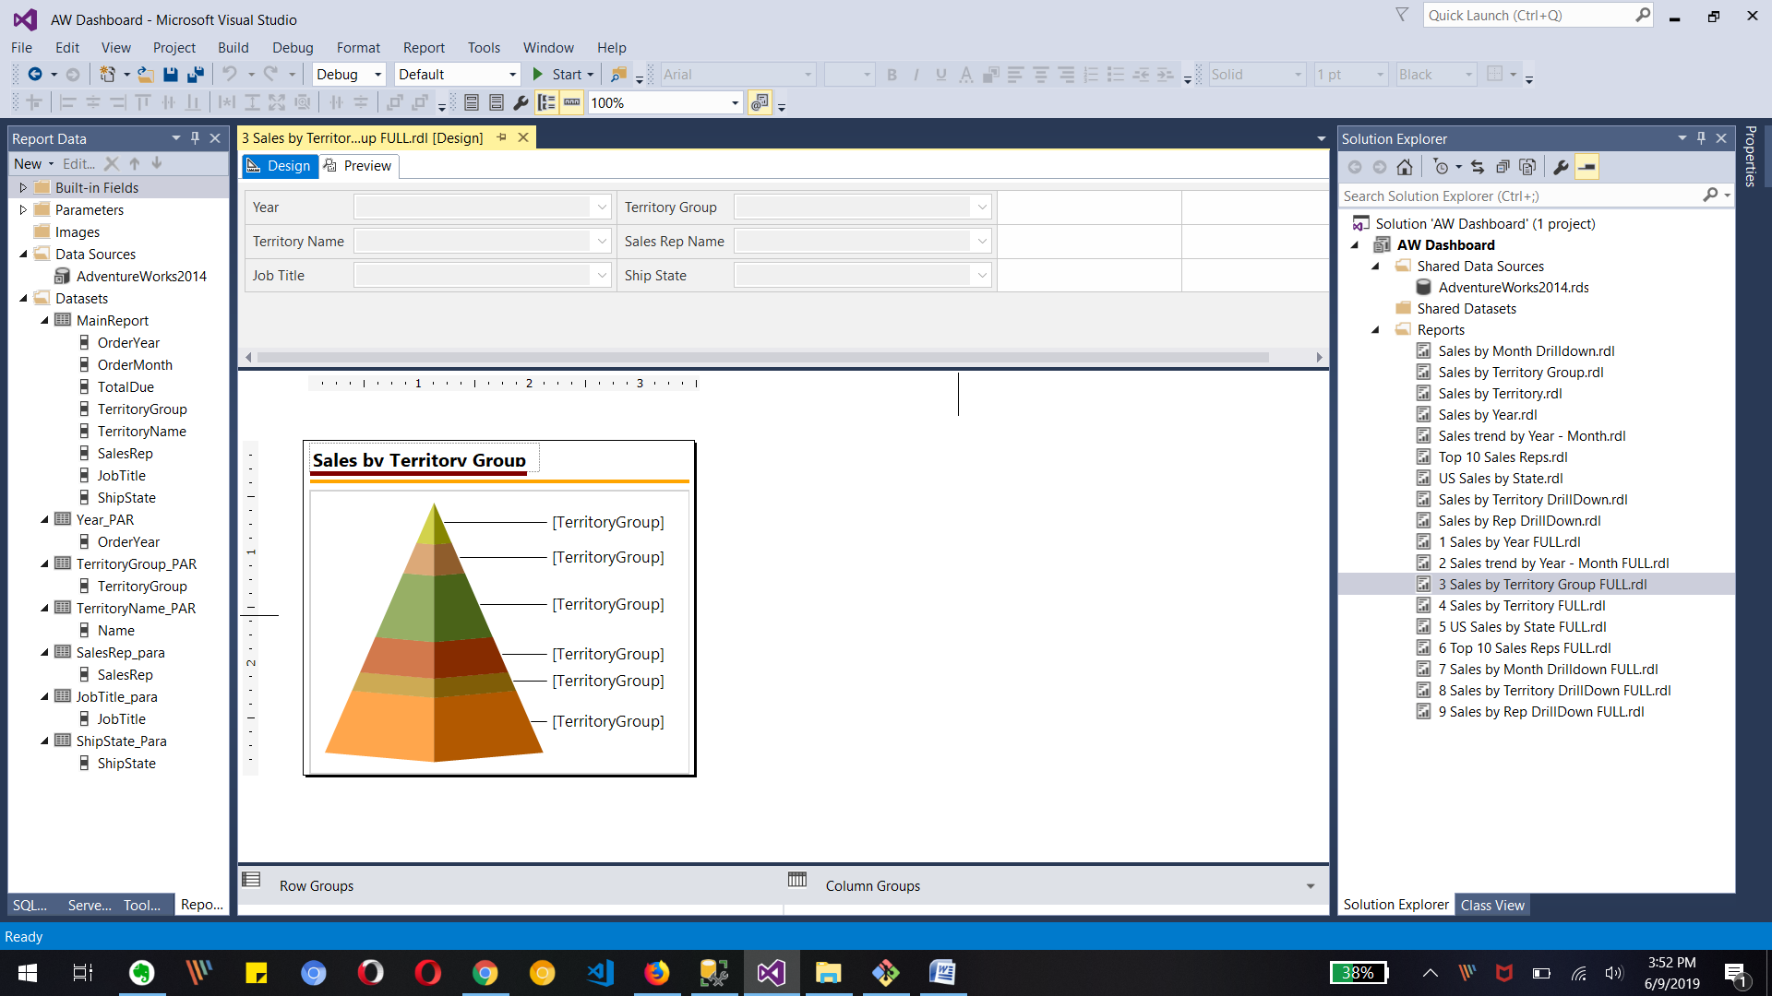

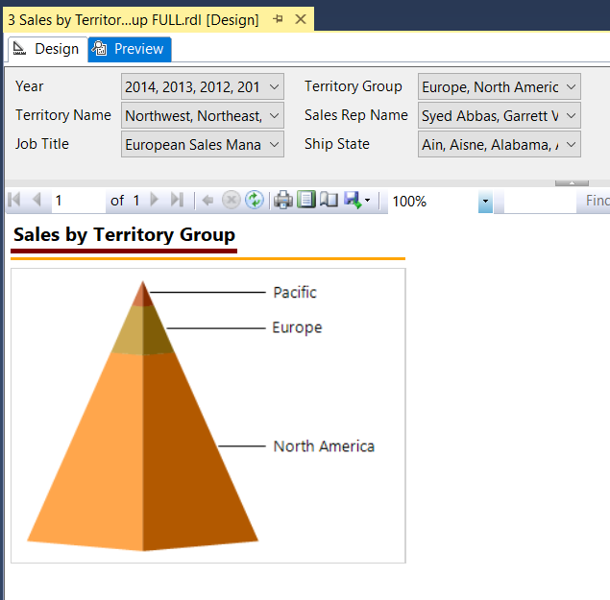Preview

This report is with all available parameters selection. So we can see the all detail for all territory and rest.

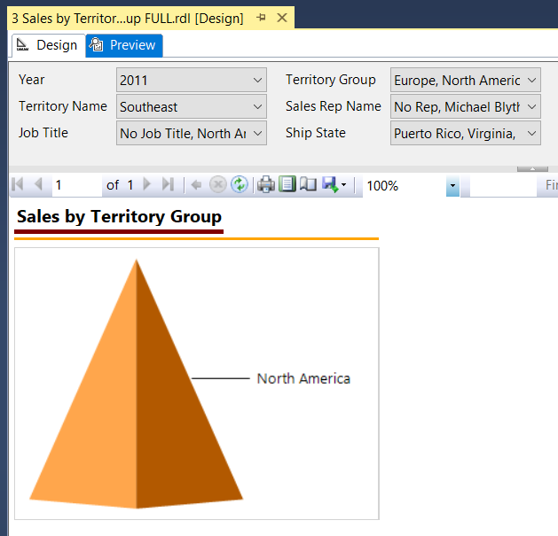The report is filtered with Year parameter as 2011 and Territory Name as Southeast and we can see the change in Territory Group is change in Graph as North America.

But no change in parameter selection for territory group as we did not code for that.  
  
4 Sales by Territory FULL

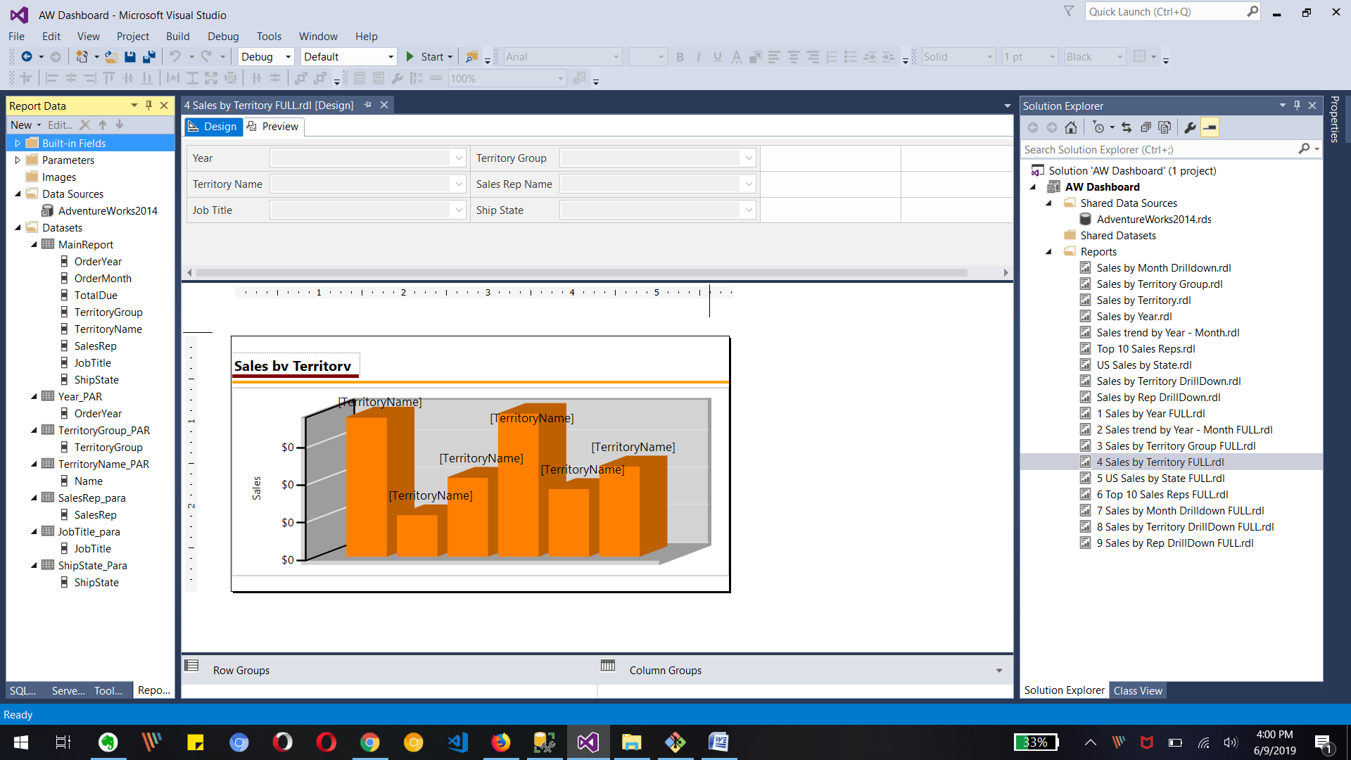

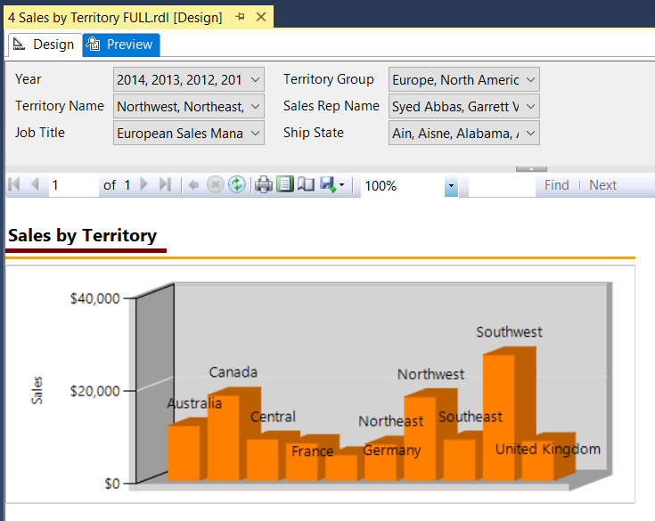The report is shown with all parameters default values selected. As we can see that in parameter section.

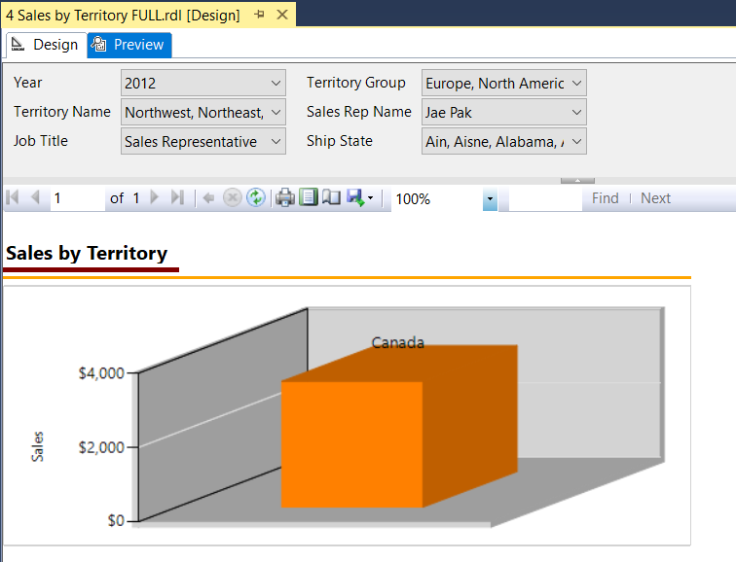The report with selected year as 2012 and Sales Rep as Jae name .

The report is shown for Canada bases on filter from parameters.

5 US Sales by State FULL

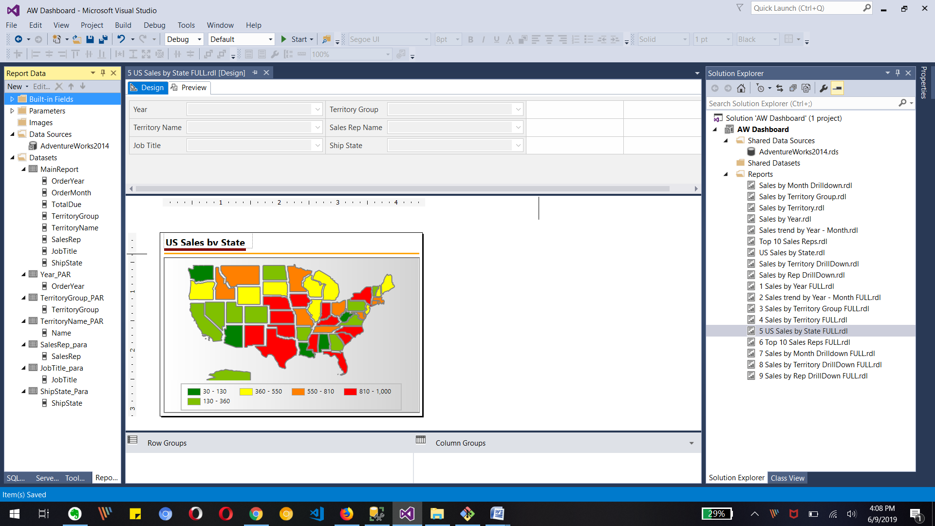

Preview

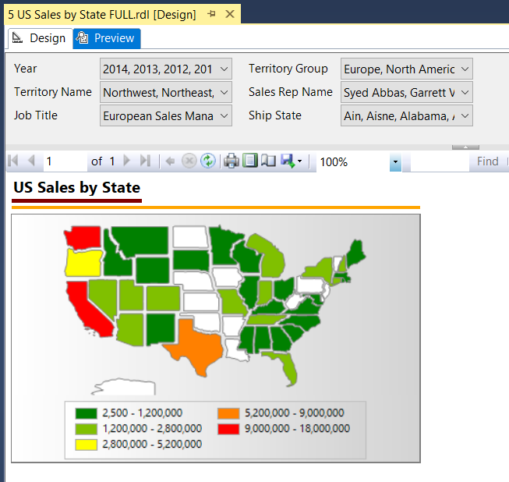The Preview for report is selected with all available parameter values. So we can see the whole map with different color.

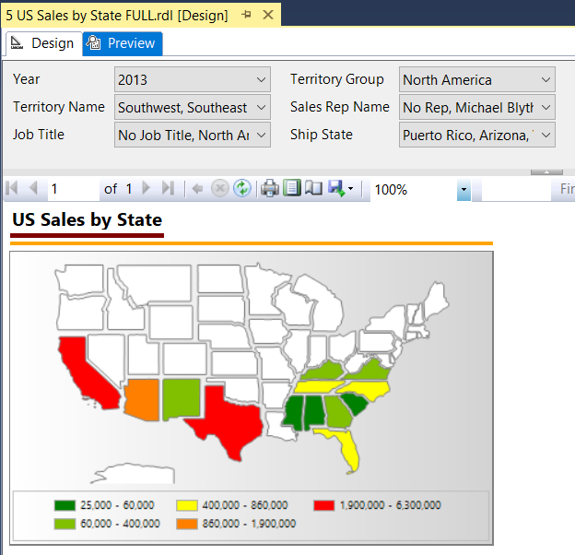This report is shown based on Parameter values as Year 2013, Territory Name Southwest and Southeast and we can see the change in the map chart.  
  
6 Top 10 Sales Reps FULL

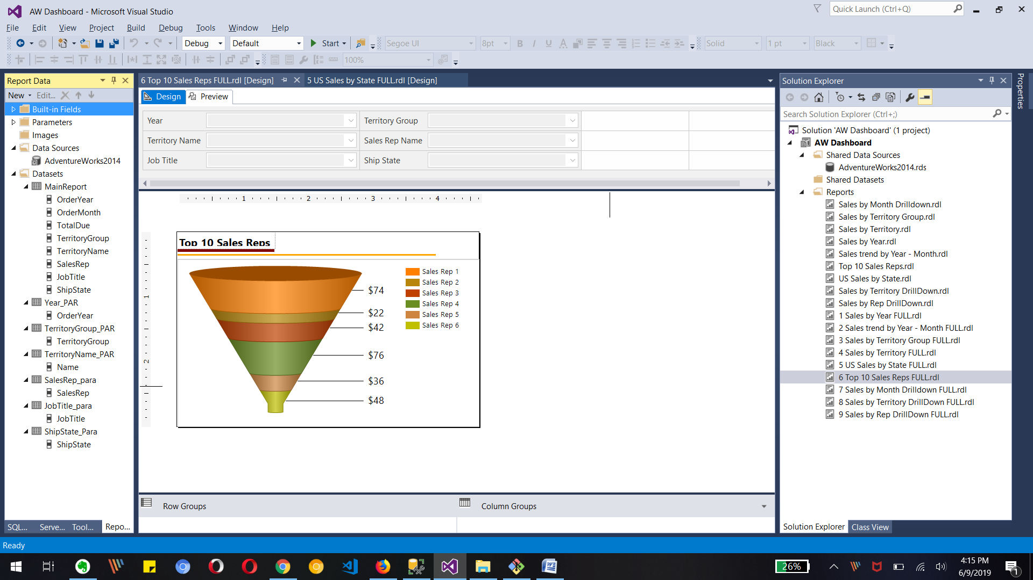

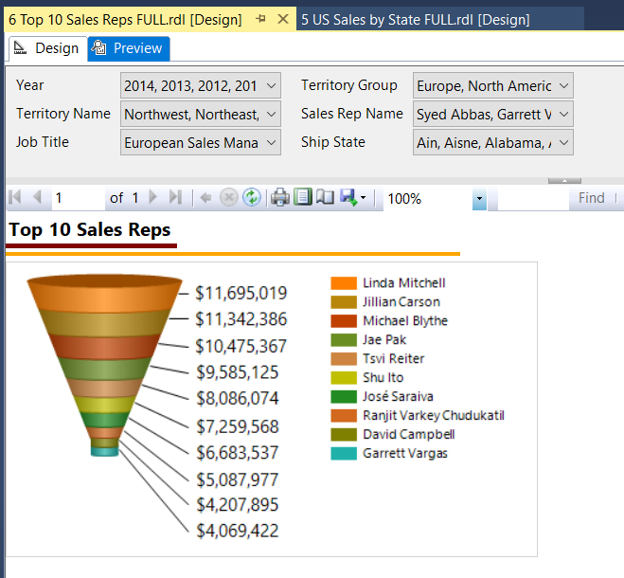

The above report is shown as all selected parameters so we can see full all Max list of sales reps in chart.

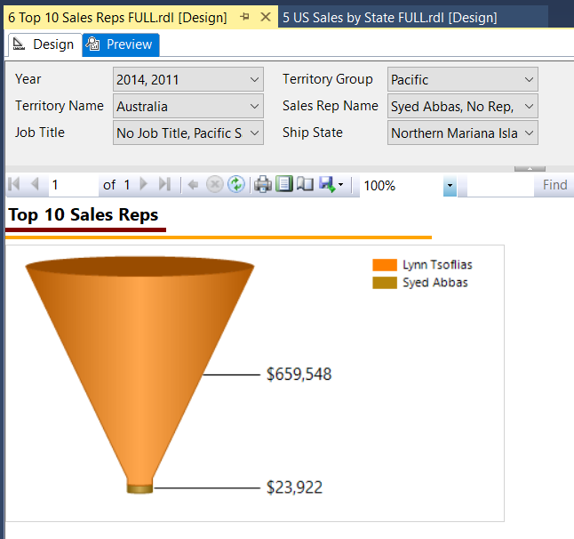

The above report is with selected parameters as Year 2014 and 2011, Territory Name as Australia.

We can see the there are only two Sales rep for Australia and that chart is shown to us.

7 Sales by Month Drilldown FULL

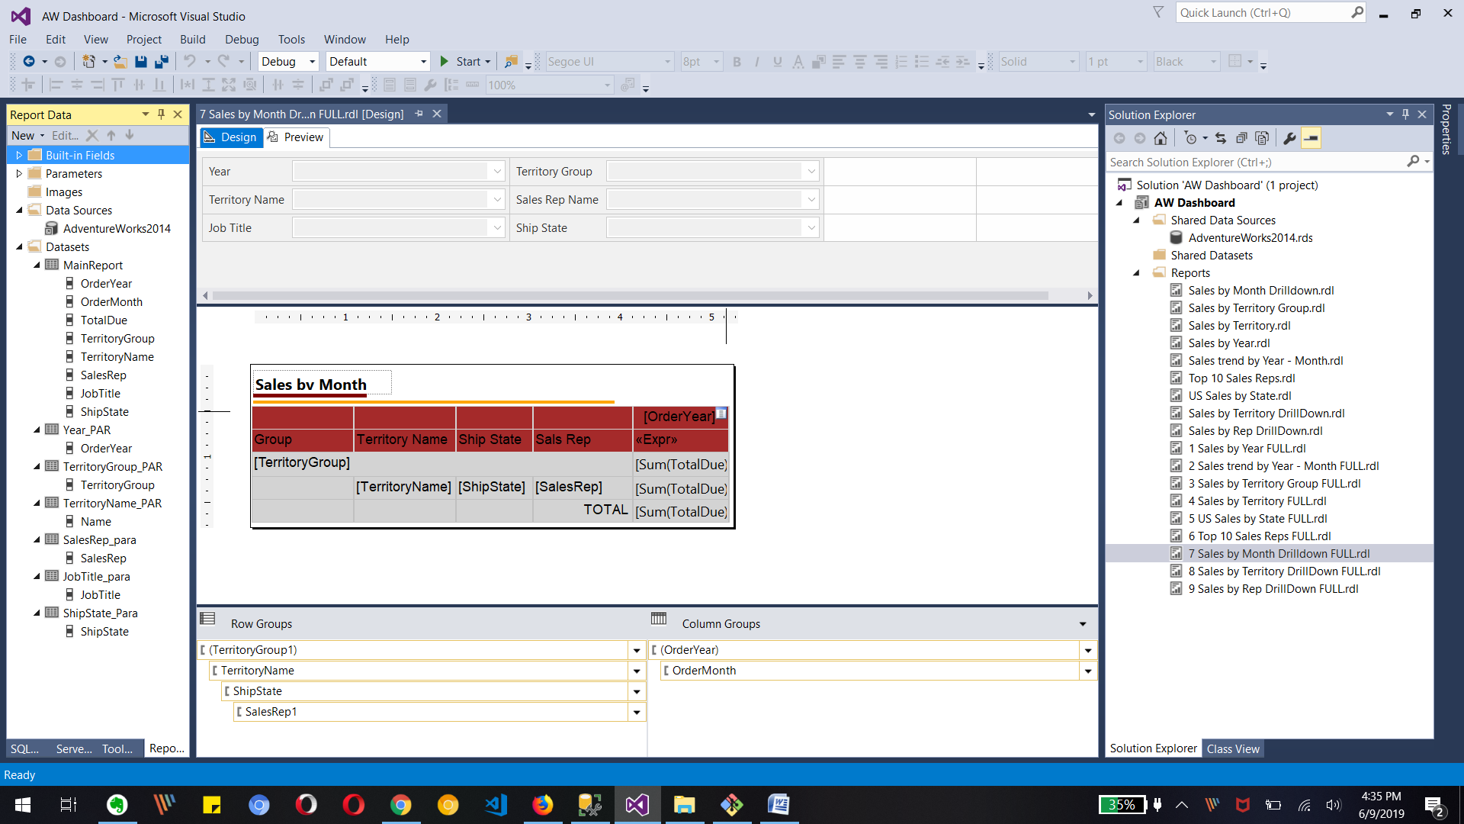

Preview

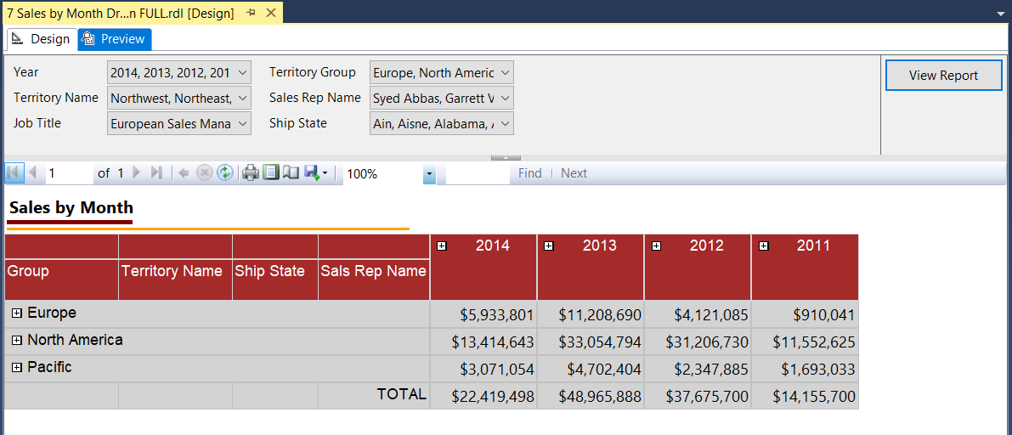

The above report with preview is with all parameters selected as default.

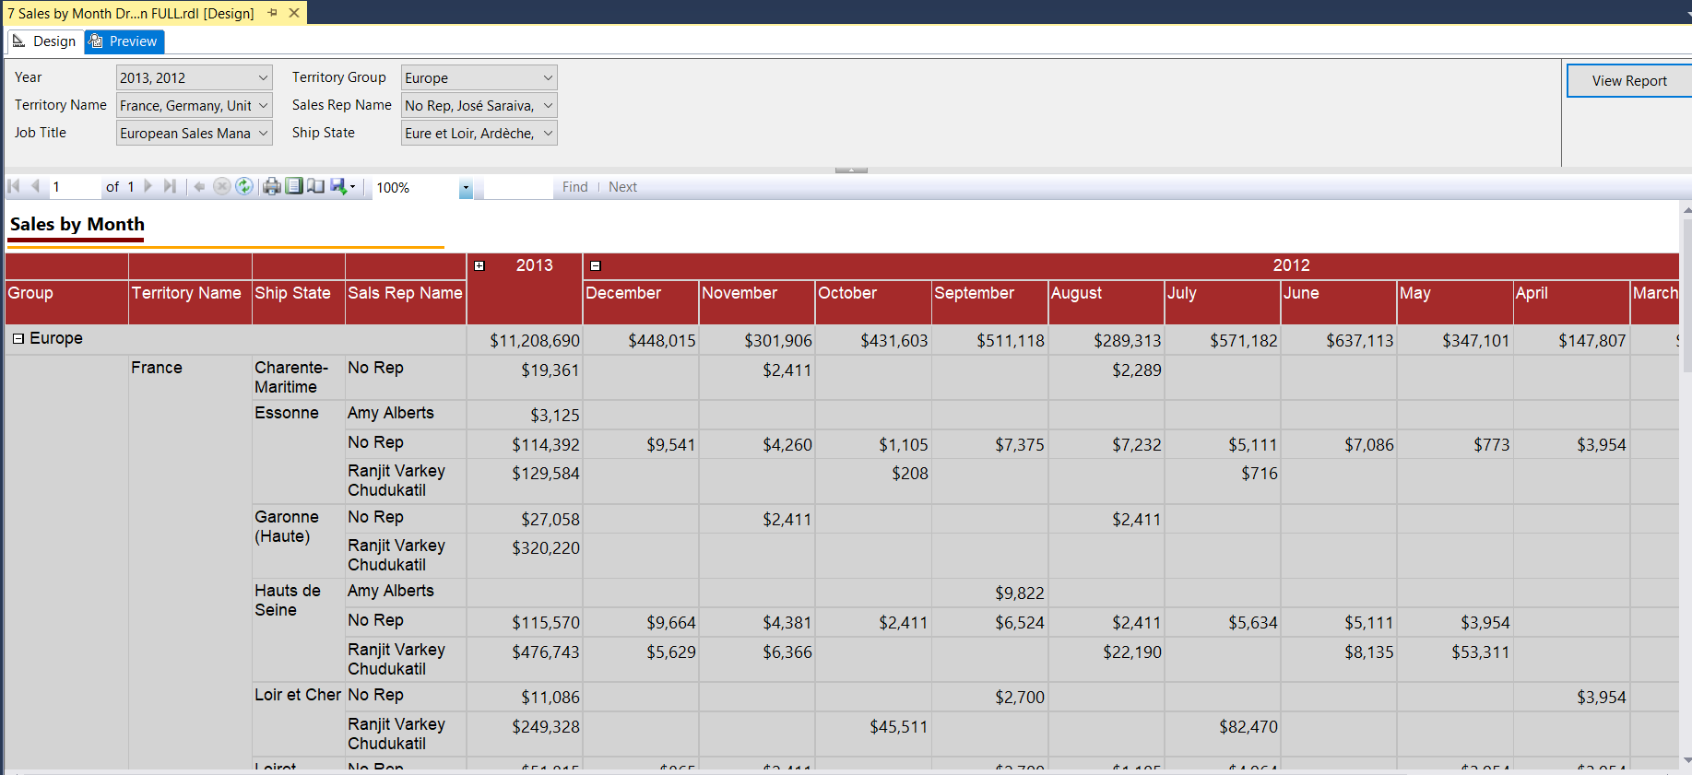

The above report is for 2013 and 2012 year with Europe Territory Group.

We can see the Europe is expanded with further detail of territory name and etc.

The same from year we can see 2012 with its relevant months total due amount.

8………… Sales by Territory DrillDown FULL

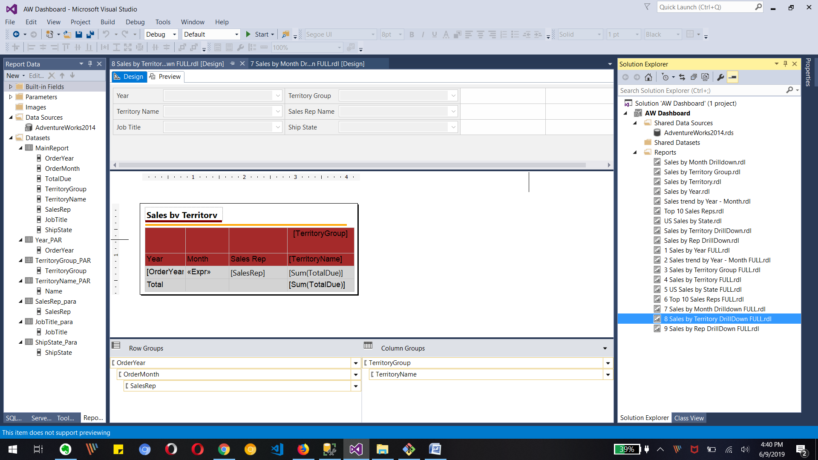

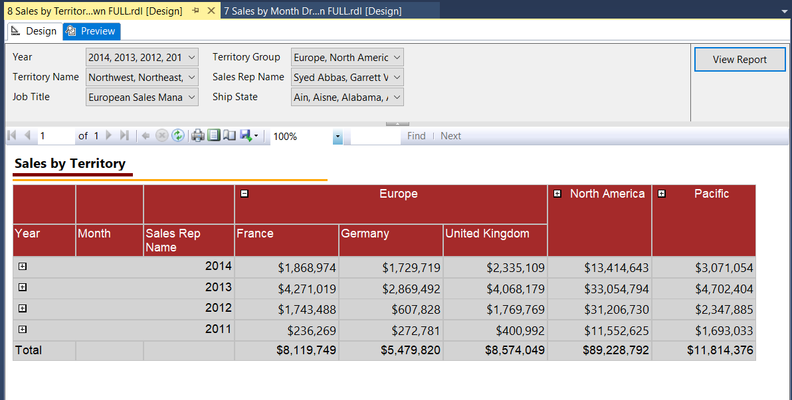

The above preview is with default all selected parameters and expanded Europe Territory group.

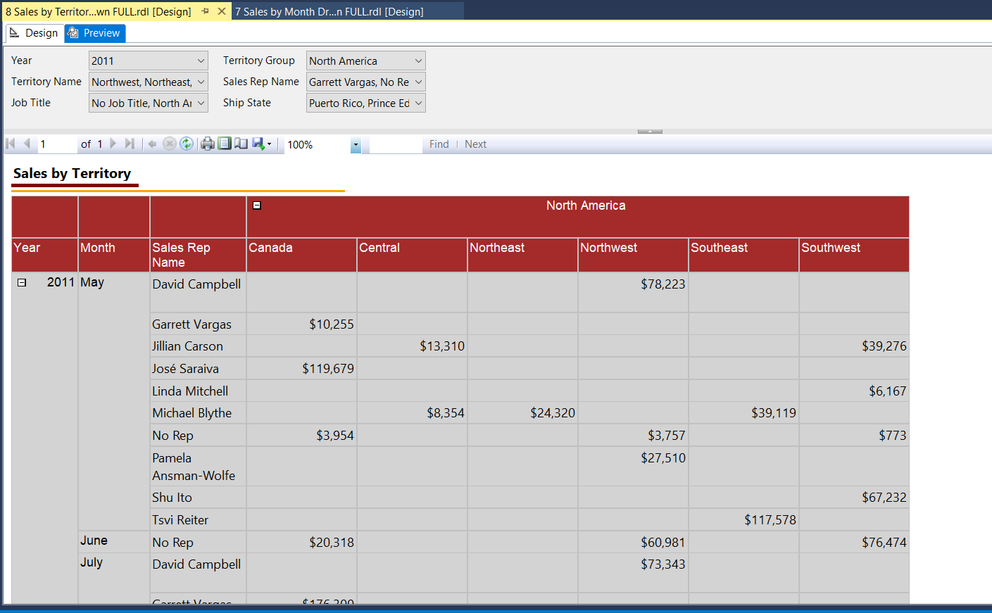

The reported is filtered with year 2011, Territory Group North America and I have expanded the Group for territory Names and Year for Month and Sales Rep Name information.

9 Sales by Rep DrillDown FULL

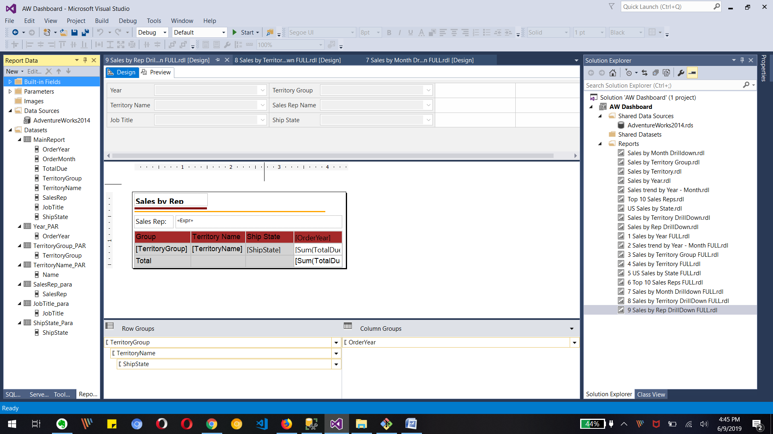

Preview

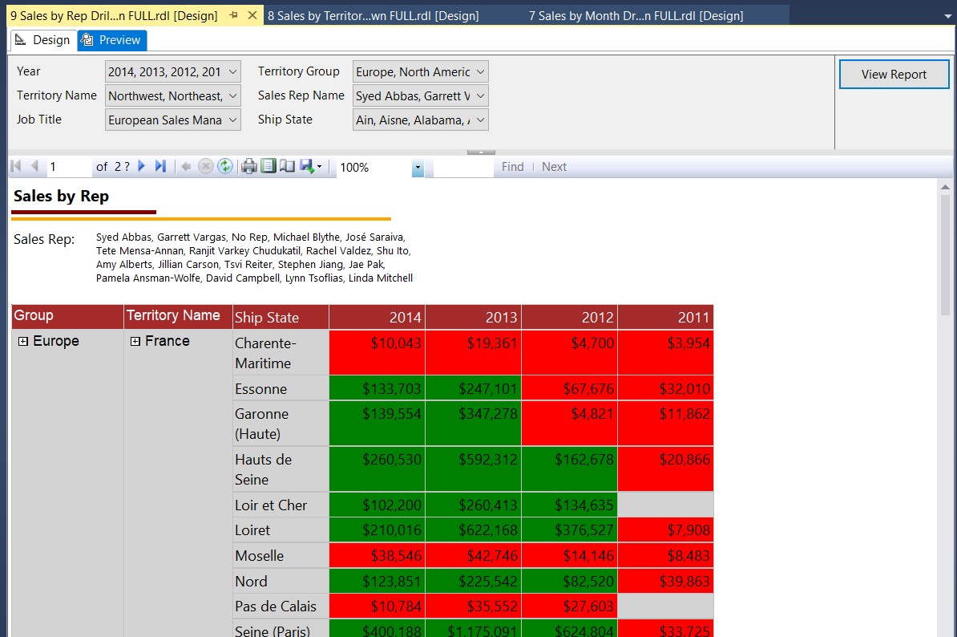

The above report is with all parameters and selected sales rep names.

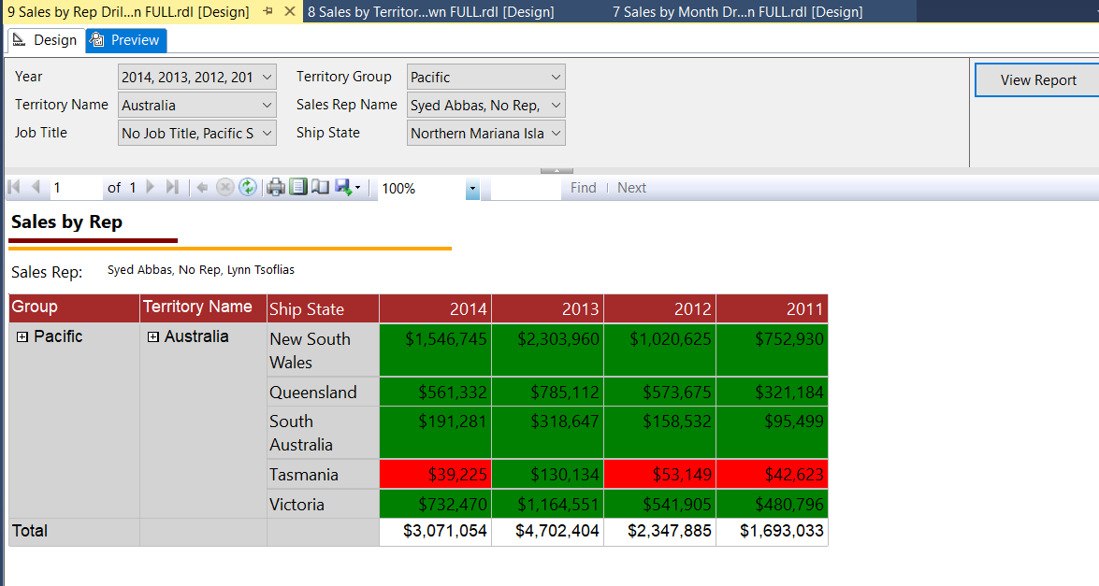

The above report is only for Australia Territory. We can see the change in graph drill down as we have only Australia in territory with its ship states name and total due. Also we can see three sales rep names in report also.

Group related information

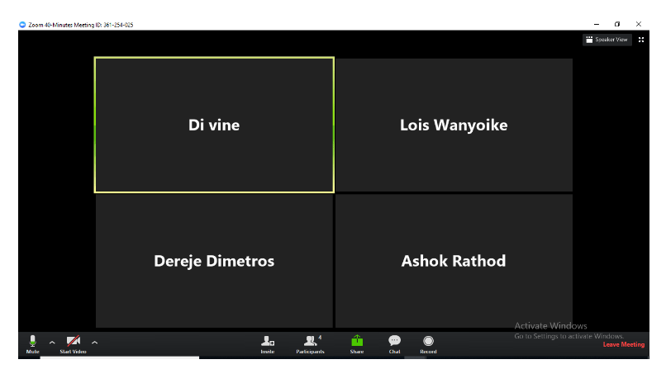

**Name: Last Completed Section**

Di Vine:  Charts and Graphs

Lois : Tables Matrix and Drilldowns

Dereje : Charts and Graphs

Ashok: Tables Matrix and Drilldowns

Dereje will be the Leader of the group….